Bootstrap –Angular 2

# Install ng2-bootstarp

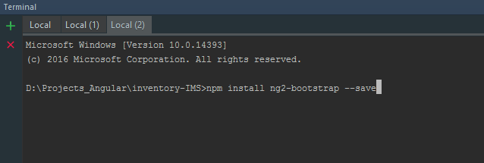

# Update bootstrap file in angular-cli.json

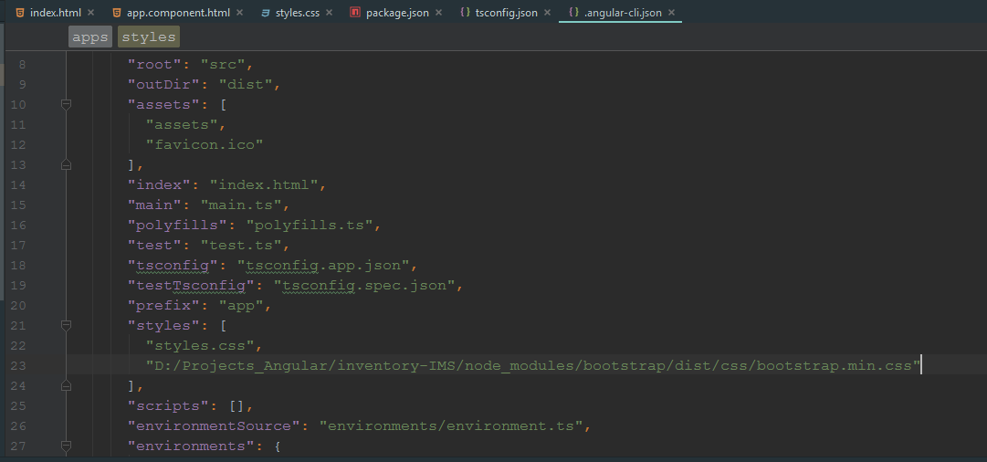

# Compile and start server

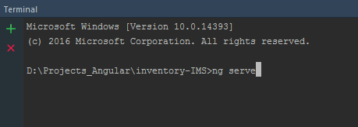

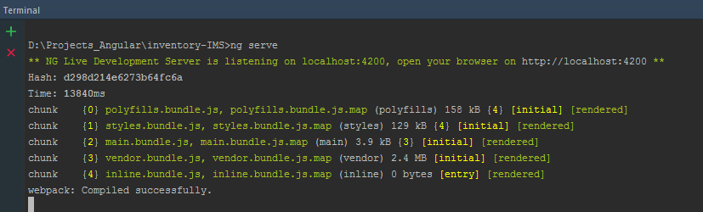

# Output

# 